Research Article | DOI: https://doi.org/10.64862/ajeg.. | Open Access

Title Maximum 3 Lines and Each Word Capital Except Conjunction and Preposition it along - Maximum length of paper is 30 pages
John Adward¹*, Manisha Dalal² and Chanda Markus²
¹KL University, Dillibazar, Kathmandu, Nepal
²Geotech Engineering, Lalitpur, Nepal
(*Corresponding E-mail: ssdetin@gmail.com)

Received: September 12, 2027, Accepted: June 15, 2028

Abstract: This is abstract. Copy and paste here as paste special>unformatted text, keeping format intact. Maximum words of abstract 300. Extended abstract is only 2-pages. Journal full paper can be of any number of pages..
Keywords: Word one, Single, Word two-2D, Word with three, Word four.

Introduction
First Paragraph no tab. It is FirstPara in Style. II. Guidelines for manuscript preparation
When you open the template, select “Print Layout” from the “View” menu in the menu bar (View | Print Layout). All text should be in Aptos font.

Abbreviations and Acronyms
Define abbreviations and acronyms the first time they are used in the text, even after they have already been defined in the abstract.
Abbreviations that incorporate periods should not have spaces: write “C.N.R.S.,” not “C. N. R. S.” Do not use abbreviations in the title unless they are unavoidable.
Table 1, This is a sample of a table title
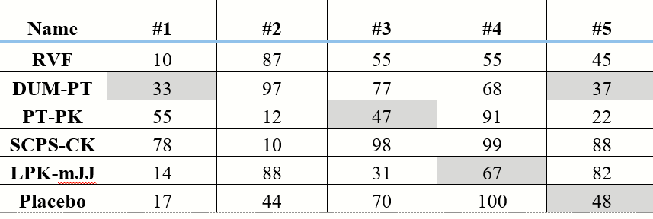

Math
Use either the Microsoft Equation Editor or the MathType plugin, which can be obtained from https://store.wiris.com/en/products/mathtype/download.

Equations
Number equations consecutively with equation numbers in parentheses flush with the right margin of the column, as in (1). First use the equation editor to create the equation. Then select the “Equation” markup style. Press the tab key and write the equation number in parentheses. To make your equations more compact, you may use the solidus ( / ), the exp function, or appropriate exponents. Use parentheses to avoid ambiguities in denominators. Punctuate equations when they are part of a sentence, as in
Bp+H_2=40 (1)
Be sure that the symbols in your equation have been defined before the equation appears or immediately following. Italicize symbols (T might refer to temperature, but T is the unit tesla). When referring to an equation or formula, use simply “(1),” not “Eq. (1)” or “equation (1),” except at the beginning of a sentence: “Equation (1) is ....”.

Guidelines for graphics preparation and submission

Types of Graphics
The following list outlines the different types of graphics. They are categorized based on their construction, and use of color / shades of gray:

Color/Grayscale Figures
Figures that are meant to appear in color, or shades of black/gray. Such figures may include photographs, illustrations, multicolor graphs, and flowcharts.

Line Art Figures
Figures that are composed of black or colored lines and shapes. These figures should have no shades or half-tones of gray, but you can use color, only black and white is also possible.

Tables
Data charts which are typically black and white, but sometimes include color.
Second paragraph with tab. It is BodyText in Style. The figures and tables must be embedded within the manuscript itself after the list of references. The original figure should be at least of half A4-sized paper in the greatest dimension. Acceptable format for the figures and images is TIF with 300-600 pixels per inch. Monochrome images, if any, should be saved in grayscale mode while color images should be in RGB mode. Only single layer images are acceptable. Every effort should be made to avoid jargon, to spell out all nonstandard abbreviations the first time they are mentioned, and to present the contents of the study as clearly and concisely as possible.

Multipart Figures
These are figures compiled of more than one sub-figure presented side-by-side or stacked. A multipart figure can be made up of multiple figure types (one part is line art, and another is grayscale or color).

Sizing of Graphics
Most charts, graphs, and tables are one column wide (3.5 inches / 88 mm / 21 picas) or page wide (7.16 inches / 181 millimeters / 43 picas). The maximum depth a graphic can be is 8.5 inches (216 millimeters / 54 picas). When choosing the depth of a graphic, please allow space for a caption.

Methodology
Figures can be sized between column and page widths if the author chooses, however, it is recommended that figures not be sized less than column width unless when necessary. First Paragraph no tab. It is FirstPara in Style. Lorem ipsum.
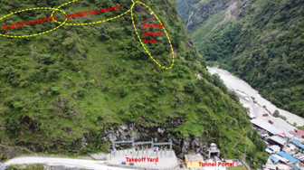 Figure 1, Caption in Style.
Second paragraph with tab. It is BodyText in Style. In ius iisque sententiae, quodsi graecis vis at. Reque quaerendum ei est, ut per vide delectus incorrupte. Vel. Has ex debet pertinax, case minimum officiis no mei.

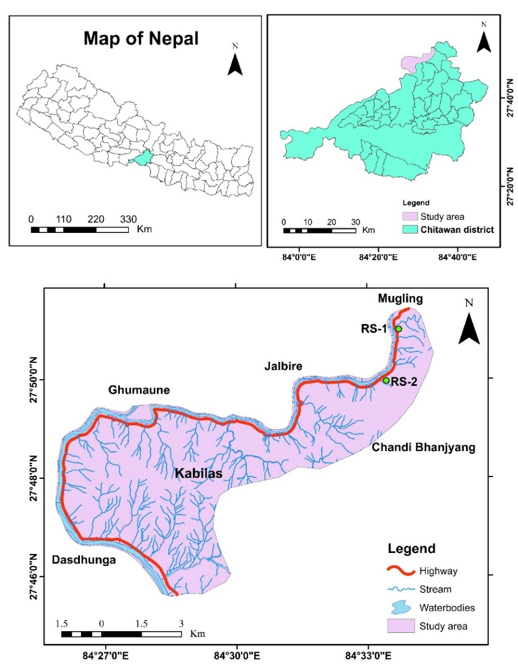
Figure 2, You can put large map in single column using column break and using single column.
In this study, these tools were applied to two representative high-risk slopes (RS-1 and RS-2) selected through systematic field assessment. Selection criteria included frequent past failures, representative geological and geotechnical conditions (weathered rock, critical discontinuities, weak overburden), proximity to essential road infrastructure, and accessibility for detailed monitoring. These slopes exemplify the failure mechanisms observed throughout the corridor. The study provides a comprehensive evaluation of slope stability, integrating field investigations, laboratory testing, rock mass classification, kinematic analysis, and numerical modeling to develop practical stabilization measures tailored to the corridor’s challenging terrain.

Heading 1
The 36 km Narayangadh–Mugling Highway corridor lies in Chitwan District, central Nepal, spanning 84°25′00″–84°35′E and 27°45′00″–27°52′30″N (Figure 1).

Heading 2
The corridor lies within the Mahabharat Synclinorium, characterized by tightly folded structures, sheared zones, and thrust faults. Lithostratigraphy resembles the Nawakot Complex (Paudyal, 2014) and includes Kuncha, Lower Siwalik, Fagfog Quartzite, Dandagaon Phyllite, Purebensi Quartzite, Amdanda Phyllite, Dhading Dolomite, and Benighat Slate (Figure 2). Dominant rocks are metasandstone, phyllite, dolomite, quartzite, slate, mudstone, sandstone, colluvium soil, and minor greenschist and hematite beds.
Elevations range from ~200 m in river valleys to 500 m along hills. The terrain is rugged, with steep slopes, deeply incised gorges, and variable lithology, creating conditions prone to slope instability.

Heading 3
The preferred spelling of the word “acknowledgment” in American English is without an “e” after the “g.” Use the singular heading even if you have many acknowledgments. Avoid expressions such as “One of us (S.B.A.) would like to thank ... .” Instead, write “F. A. Author thanks ... .” In most cases, sponsor and financial support acknowledgments are placed.

Supplementary materials
Any supplementary materials can be submitted online while submitting through https://ajeg.nseg.org.np. It will attached with published paper after acceptance as supplementary material.

Acknowledgements
Special thanks to Geotech Solutions International for valuable support. We are thankful to two anonymous reviewers for their comments and suggestions, which helped to rectify the manuscript.

Author contributions
Shankar wrote the main manuscript text, Manita and Kabita prepared figures and revise the article. All authors also reviewed it.

Data availability
No datasets were generated or analyzed during this study.

Declarations
The authors declare that they have no known competing financial interests or personal relationships that could have appeared to influence the work reported in this article.

Reference style
AJEG prefers maximum 60 references per article. The journal follows the Harvard system for citation, with author name/s and year of publication in parentheses, such as one author: (Hungr, 2003) or Hungr (2003), two authors: (Doe and Morris, 2009; Dahal et al., 2015) or Doe and Morris (2009), and three authors or more: (Rahardjo et al., 2002) or Rahardjo et al. (2002). Write DOI in last as far as available. Please follow the APA reference style. However, use "and" instead of "&", and do not use italics for the journal name or volume number. Examples are provided below.
Ahmad, R., and Joshi, M. N. (2010). Assessment of landslide susceptibility on land degradation processes in Chamoli and surrounding areas using RS and GIS technique. International Geoinformatics Research and Development Journal, 1(3).
Aleotti, P., and Chowdhury, R. (1999). Landslide hazard assessment: Summary review and new perspectives. Bulletin of Engineering Geology and the Environment, 58(1), 21–44. https://doi.org/10.1007/s100640050066
Baharvand, M., and Hosseinitoudeshki, V. (2015). The effect of installation angle of rock bolts on the stability of rock slopes. Journal of Novel Applied Sciences, 4(1), 67–71.
Bieniawski, Z. T. (1973). Engineering classification of jointed rock masses. Civil Engineering (South Africa), 15, 335–344.
Bieniawski, Z. T. (1976). Rock mass classifications in engineering. In Proceedings of the Symposium on Exploration Rock Engineering (pp. 97–106). Johannesburg.
Bieniawski, Z. T. (1989). Engineering rock mass classification. Wiley.
Brunsden, D., Jones, D. K. C., Martin, R. P., and Doornkamp, J. C. (1981). The geomorphological character of part of the Low Himalaya of eastern Nepal. Zeitschrift für Geomorphologie Supplementband, 40, 25–72.
Duncan, J. M., Wright, S. G., and Brandon, T. L. (2005). Soil strength and slope stability (2nd ed.). John Wiley and Sons.
Gerrard, J. (1994). The landslide hazard in the Himalayas: Geological control and human action. Geomorphology, 10(3), 221–230. https://doi.org/10.1016/0169-555X(94)90041-8
Goodman, R. E. (1995). Block theory and its application. Géotechnique, 45(3), 383–423. https://doi.org/10.1680/geot.1995.45.3.383
Goodman, R. E. (2000). Introduction to rock mechanics. John Wiley and Sons.
Haswanto, W. A., and Abd-Ghani, R. (2008). Kinematic and block theory applications to rock slope stability analysis at Fraser’s Hill, Pahang, Malaysia. Electronic Journal of Geotechnical Engineering, 13(D).
Hoek, E., and Bray, J. W. (1981). Rock slope engineering (3rd ed.). Institute of Mining and Metallurgy.
Kainthola, A., Singh, P. K., and Singh, T. N. (2015). Stability investigation of road-cut slope in basaltic rock mass, Mahabaleshwar, India. Geoscience Frontiers, 6(6), 837–845. https://doi.org/10.1016/j.gsf.2014.06.006
Khanal, S., and Dahal, R.K. (2024). Influence of Precipitation Variability on Pore Water Pressure and Surface Layer Failures in Naturally Undulating Slopes at Nau Kilo, Narayanghat–Mugling Road, Central Nepal. Asian Journal of Engineering Geology, 1(1 and 2), 39-48. https://doi.org/10.64862/ajeg.112.05
Kliche, A. C. (1999). Rock slope stability. Society for Mining, Metallurgy, and Exploration.
OnlineKhabar (2017). Two killed, Two missing as landslide buries police van in Chitwan. Available at: https://english.onlinekhabar.com/2-killed-2-missing-as-landslide-buries-police-van-in-chitwan.html
Owen, L. A. (1991). Mass movement deposits in the Karakoram Mountains: Their sedimentary characteristics, recognition, and role in landform evolution. Geomorphology, 35(4), 401–424. https://doi.org/10.1016/0169-555X(91)90007-E
Paudyal, K. (2014). Geological and petrological evolution of Mugling–Damauli area of central Nepal, Lesser Himalaya (Doctoral dissertation). Tribhuvan University, Nepal.
Regmi, A. D., Yoshida, K., Dhital, M. R., and Devkota, K. (2013a). Effect of rock weathering, clay mineralogy, and geological structures on the formation of a large landslide: A case study from Dumre Besei, Lesser Himalaya, Nepal. Landslides, 10(4), 483–494. https://doi.org/10.1007/s10346-011-0311-7
Regmi, A. D., Devkota, K. C., Yoshida, K., Pradhan, B., Pourghasemi, H. R., Kumamoto, T., and Akgün, K. (2013b). Application and comparison of frequency ratio, statistical index, and weights-of-evidence models in landslide susceptibility mapping in central Nepal Himalaya. Arabian Journal of Geosciences, 6(7), 2727–2743. https://doi.org/10.1007/s12517-012-0807-z
Rocscience. (2006). Slide 5.0: 2D limit equilibrium slope stability analysis [Computer software]. Rocscience Inc.
Romana, M. (1985). New adjustment ratings for application of Bieniawski classification to slopes. In International Symposium on the Role of Rock Mechanics (ISRM) (pp. 49–53). Zacatecas.
Romana, M. (1995). The geomechanics classification SMR for slope correction. In Proceedings of the 8th International ISRM Congress (pp. 1085–1092).
Sharma, R. K., Mehta, B. S., and Jamwal, C. S. (2013). Cut slope stability evaluation of NH-21 along the Natayan–Gambhrola section, Bilaspur District, Himachal Pradesh, India. Natural Hazards, 66(1), 249–270. https://doi.org/10.1007/s11069-012-0469-x
Shroder, J. F., and Bishop, M. P. (1998). Mass movement in the Himalaya: New insights and research directions. Geomorphology, 26(1–3), 13–35. https://doi.org/10.1016/S0169-555X(98)00052-7
Singh, P. K., Kainthola, A., and Singh, T. N. (2013). Rock mass assessment along the right bank of the River Sutlej, Luhri, Himachal Pradesh, India. Geomatics, Natural Hazards and Risk, 5(3), 205–222. https://doi.org/10.1080/19475705.2013.834486
Umrao, R. K., Singh, R., Ahmad, M., and Singh, T. N. (2011). Stability analysis of cut slopes using continuous slope mass rating and kinematic analysis in Rudraprayag District, Uttarakhand. Geomaterials, 1(2), 79–87. https://doi.org/10.4236/gm.2011.12012
World Bank (2025). Protecting slopes to build resilient roads in Nepal. Available at: https://www.worldbank.org/en/news/feature/2025/02/10/protecting-slopes-to-build-resilient-roads-in-nepal

